**BIS 698 - Information Systems**

**Master of Science in Information Systems**

**Housing Management System**

**Client: BrightStay Housing**

**Date – 02/01/2025**

**Submitted By**

**Sai Nikhitha**

**Anbu Arasan**

**Sai Kumar Kurapati**

**Venugopal Rao Jupalli**

Contents

1. Background 1

2. Business Problems & Opportunities 1

3. Project Description 2

4. Project Feasibility 3

5. Use Cases 4

6.Context Diagram: 6

7.0 Task List 11

8.0 Critical Path 12

9.0 ERD 13

10.Screens Designs 14

11. Conclusion 19

BrightStay Housing is a student accommodation management company that provides affordable and well-organized hostel accommodation for students across multiple university campuses. The company ensures a seamless stay for students by managing room allocations, rent payments, maintenance requests, and visitor tracking. However, their current manual system has led to inefficiencies in managing accommodations, payments, and maintenance requests, prompting the need for a digital solution.

## 1. Background

Managing hostel accommodation efficiently is a significant challenge for universities and rental property managers. Traditional hostel management relies on manual processes, making it difficult to track student accommodation, rent payments, maintenance requests, and guest visits.

The **Housing Management System** is designed to streamline hostel operations by digitizing student registration, room allocation, rent tracking, maintenance requests, and visitor management. This system will provide an intuitive interface for students and administrators to manage accommodation efficiently.

## 2. Business Problems & Opportunities

BrightStay Housing faces several key challenges that this system aims to resolve:

* **Manual room allocation** – Inefficient and time-consuming student room assignment process.
* **Difficulty in rent tracking** – No structured system to track monthly payments and fines for late payments.
* **Lack of structured maintenance handling** – Students struggle to report issues, leading to delayed repairs.
* **Guest entry mismanagement** – No centralized guest tracking system for security purposes.
* **Inefficient leave request system** – No standardized process for students to submit leave/exits.
* **Limited report generation capabilities** – Lack of automated occupancy and financial reporting.

**Opportunities:**

* **Improved Administrative Efficiency** – Automating room allocation and rent tracking reduces workload.
* **Better Student Experience** – Faster response to maintenance requests and clear payment records.
* **Data-Driven Decision Making** – Reports help management track occupancy trends and finances.

## 3. Project Description

#### 3.1 System Purpose

The **Housing Management System** aims to modernize hostel administration by offering features such as:

* **Student registration & room allocation** – Assign students to rooms automatically based on availability.
* **Monthly rent tracking** – Maintain records of payments and generate invoices.
* **Maintenance request system** – Enable students to submit maintenance complaints digitally.
* **Leave/Exit request management** – Provide a streamlined process for students to submit leave requests.
* **Payment & fine calculation** – Automatically calculate fines for late payments.
* **Guest entry log** – Track and manage visitor records for security.
* **Report generation** – Generate and export reports in PDF format.

#### 3.2 Core Functional Requirements

**For Students:**

* Online student registration.
* Log guest entry details.
* Room allocation and viewing assigned room details.
* Submit maintenance/complaint requests.
* Pay monthly rent.
* Submit leave/exit requests.

**For Hostel Admins/Managers:**

* Manage student registrations and room allocations.
* Approve or reject maintenance requests.
* Approve leave requests.
* Maintain guest entry logs.
* **Generate reports**, including:
  + Monthly financial reports
  + Student occupancy reports

#### 3.3 Out-of-Scope Features

* **AI-based room allocation optimization** – Room assignments will be manual or rule-based.
* **Real-time payment processing** – The system will generate invoices, but payment integration is not included.
* **Mobile app support** – Initially developed as a desktop application.
* **Live Payments** – Tracking of payments will be manual.
* **Biometric-based guest entry** – Guest entry will be logged manually.
* **Automated maintenance request prioritization** – Maintenance requests will be handled manually.
* **Advanced analytics and predictive insights** – Reports will be simple and not include advanced analytics.

## 4. Project Feasibility

#### 4.1 Economic Feasibility

The system is cost-effective as it eliminates the need for manual record-keeping, reducing the administrative workload. It provides a structured rental tracking system that minimizes revenue losses due to delayed payments.

Additionally, **the system offers a strong return on investment (ROI)** by reducing administrative overhead and improving operational efficiency. The benefits include:

* Time savings for administrators
* Reduced paperwork costs
* Improved financial tracking, leading to better budgeting

| **Cost Component** | **Estimated Cost (USD)** |
| --- | --- |
| Software Development | $4,000 - $6,000 |
| Database & Hosting | $500 - $1,000 |
| Maintenance & Support | $700 per year |
| Training & Documentation | $600 |
| Total Estimated Cost | $5,800 - $8,300 |

#### 4.2 Technical Feasibility

The system is technically feasible using the following stack:

* **Frontend:** Tkinter (Python-based GUI for registration and dashboard UI)
* **Backend:** SQLite/MySQL (for database management)
* **PDF Report Generation:** Python libraries such as ReportLab or FPDF

Since these technologies are well-documented and widely used, the project is technically feasible for implementation.

#### 4.3 Schedule Feasibility

The project is expected to be completed within one academic term. The development timeline is structured as follows:

| **Phase** | **Duration** |
| --- | --- |
| System Design & Database Setup | Week 1-2 |
| Frontend & Backend Development | Week 3-4 |
| Integration of Core Functionalities | Week 5-6 |
| Testing & Final Refinements | Week 7-8 |

#### 4.4 Operational Feasibility

The system is designed with simplicity to ensure ease of use for students and hostel administrators. Minimal training will be required for adoption, and a user-friendly interface will be implemented.

## 5. Use Cases

#### 5.1 Student Registration

|  |
| --- |
| **Use Case Name:** Student Registration **ID:** UC-1 **Priority:** High |
| **Actor:** Student |
| **Description:** Allows students to register and access the system. |
| **Trigger:** A new student wants to create an account. |
| **Preconditions:**   1. The system is accessible online. |
| **Normal Flow:**   1. Students navigate to the registration page. 2. Fill in the registration form with name, email, and password. 3. Submits the form. 4. The system validates email and stores user data. 5. The system confirms registration. |
| **Postconditions:**   1. The student is registered and can log in. |

#### 5.2 Student Login

|  |
| --- |
| **Use Case Name:** Student Login **ID:** UC-2 **Priority:** High |
| **Actor:** Student |
| **Description:** Allows students to log into the system. |
| **Trigger:** A registered student attempts to log in. |
| **Preconditions:**   1. The student must be registered. |
| **Normal Flow:**   1. Students navigate to the login page. 2. Enters login credentials. 3. System validates credentials. 4. If valid, access is granted; otherwise, an error message is displayed. |
| **Postconditions:**   1. The student gains access to their account. |

#### 5.3 Room Allocation

|  |
| --- |
| **Use Case Name:** Room Allocation **ID:** UC-3 **Priority:** High |
| **Actor:** Student, Admin |
| **Description:** Assigns rooms to students automatically or manually |
| **Trigger:** A student completes registration. |
| **Preconditions:**   1. The student is registered, and rooms are available. |
| **Normal Flow:**   1. Admin accesses the room allocation module. 2. The system suggests an available room based on predefined rules. 3. Admin approves or modifies the room assignment. 4. System updates room allocation records. |
| **Postconditions:**   1. The student is assigned a room. |

#### 5.4 Rent Payment

|  |
| --- |
| **Use Case Name:** Rent Payment **ID:** UC-4 **Priority:** High |
| **Actor:** Student |
| **Description:** Enables students to track and pay their rent. |
| **Trigger:** Student initiates a rent payment. |
| **Preconditions:**   1. Students are logged in and rent is due. |
| **Normal Flow:**   1. Student navigates to the payment section. 2. System displays rent is due. 3. Student selects payment methods and confirms payment. 4. The system updates payment records. |
| **Postconditions:**   1. Rent is marked as paid. |

#### 5.5 Maintenance/Complaint Request

|  |
| --- |
| **Use Case Name:** Maintenance/Complaint Request **ID:** UC-5 **Priority:** High |
| **Actor:** Student, Admin |
| **Description:** Allows students to submit maintenance complaints and track resolution. |
| **Trigger:** Student experiences a maintenance issue. |
| **Preconditions:**   1. Students are logged in. |
| **Normal Flow:**   1. Student navigates to maintenance request section. 2. Submits details of the issue. 3. System logs request and notifies admin. 4. Admin assigns maintenance staff. 5. Staff resolves issue and updates status. |
| **Postconditions:**   1. Maintenance requests are addressed. |

#### 5.6 Leave/Exit Request Management

|  |
| --- |
| **Use Case Name:** Leave/Exit Request Management **ID:** UC-6 **Priority:** Medium |
| **Actor:** Student, Admin |
| **Description:** Allows students to submit leave or exit requests. |
| **Trigger:** A student wants to leave the hostel temporarily or permanently. |
| **Preconditions:**   1. Students are logged in. |
| **Normal Flow:**   1. Student submits a leave request with dates and reason. 2. Admin reviews the request. 3. Admin approves or rejects the request. |
| **Postconditions:**   1. Leave requests are approved or denied. |

#### 5.7 Report Generation

|  |
| --- |
| **Use Case Name:** Report Generation **ID:** UC-7 **Priority:** High |
| **Actor:** Admin |
| **Description:** Generates occupancy reports. |
| **Trigger:** Admin requests a report. |
| **Preconditions:**   1. The system has sufficient data. |
| **Normal Flow:**   1. Admin selects report type (occupancy, finance, maintenance). 2. The system fetches relevant data. 3. Report is generated and exported as PDF. |
| **Postconditions:**   1. Reports are generated and stored for reference. |

## 6.Context Diagram:

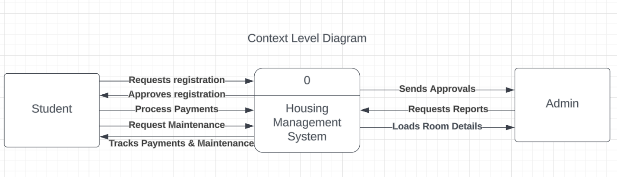

#### 6.1 Level 0 DFD

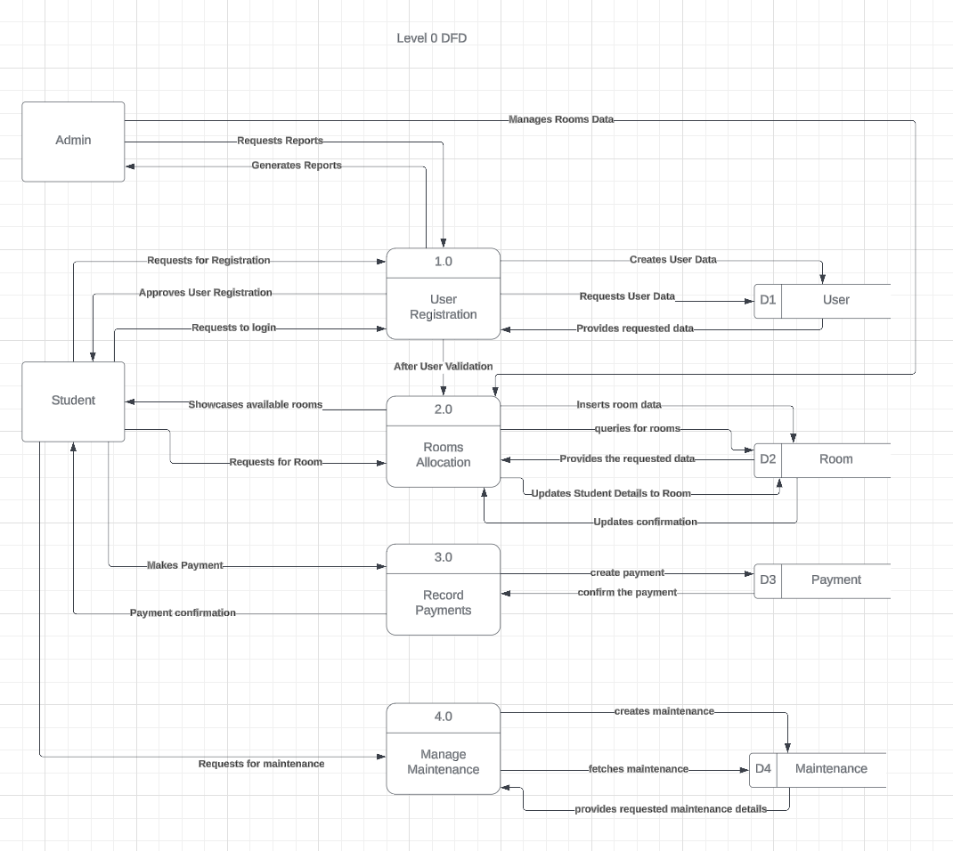

#### 6.2 Process Model with Data Flow Diagram (DFD)

**Entities and Data Stores:**

1. **Student (User)**
   * The primary actor who interacts with the system to register, request rooms, pay rent, and submit maintenance requests.
   * Students can also log guest entries and receive room allocation details.
2. **Admin**
   * Responsible for approving student registrations, allocating rooms, processing payments, and handling maintenance requests.
   * Admin generates reports and ensures system operations run smoothly.
3. **Data Stores (System Databases)**
   * **D1: User Data Store –** Stores student registration details and login credentials.
   * **D2: Room Data Store –** Holds room allocation details and availability.
   * **D3: Payment Data Store –** Maintains records of rent payments.
   * **D4: Maintenance Data Store** – Stores details of maintenance requests and their resolution status.

**Processes and Their Functions:**

**1.0 User Registration**

* **Purpose:** Allows students to create an account for hostel management.
* **Input:** Student enters name, email, password to sign up**.**
* **Process:**
  1. The student accesses the registration page.
  2. The system validates user details (checks if email already exists).
  3. If validation is successful, the system stores the user’s details in D1: User Data Store.
* **Output:**
  1. If registration is successful, the student can log in.
  2. If registration fails (e.g., duplicate email), an error message is displayed.

**2.0 Room Allocation**

* **Purpose:** Assigns rooms to students and allows them to view room details.
* **Input**: Student requests a room.
* **Process:**
  1. Student requests room allocation.
  2. System queries D2: Room Data Store for available rooms.
  3. Admin approves room assignment.
  4. System updates D2 with the new allocation.
  5. Students receive room allocation confirmation**.**
* **Output:**
  1. Room is allocated successfully.
  2. Students can view room details.

**3.0 Record Payments**

* **Purpose:** Allows students to pay rent and track payment history.
* **Input:** Student makes payment.
* **Process:**
  1. Students initiate rent payment.
  2. The system fetches payment details from D3: Payment Data Store.
  3. Payment is processed and recorded in D3.
  4. Payment confirmation is sent to the student.
* **Output:**
  1. Rent is marked as paid.
  2. Receipt is generated for the student.

**4.0 Manage Maintenance**

* **Purpose:** Handles maintenance requests submitted by students**.**
* **Input:** Student submits a maintenance request.
* **Process:**
  1. Student submits a maintenance request.
  2. System logs the request in D4: Maintenance Data Store.
  3. Admin reviews and assigns maintenance staff.
  4. Staff update the system once the issue is resolved.
  5. Students receive maintenance completion notification.
* **Output:**
  1. The maintenance issue is resolved.
  2. Status updates are sent to the student.

**Data Flows in the System:**

1. **Student Registration:** Data is stored in D1 (User Data Store).
2. **Room Allocation:** System retrieves availability from D2 (Room Data Store) and assigns rooms.
3. **Rent Payment**: Payments are processed and stored in D3 (Payment Data Store).
4. **Maintenance Requests:** Student requests are logged, assigned, and updated in D4 (Maintenance Data Store).

## 7.0 Task List

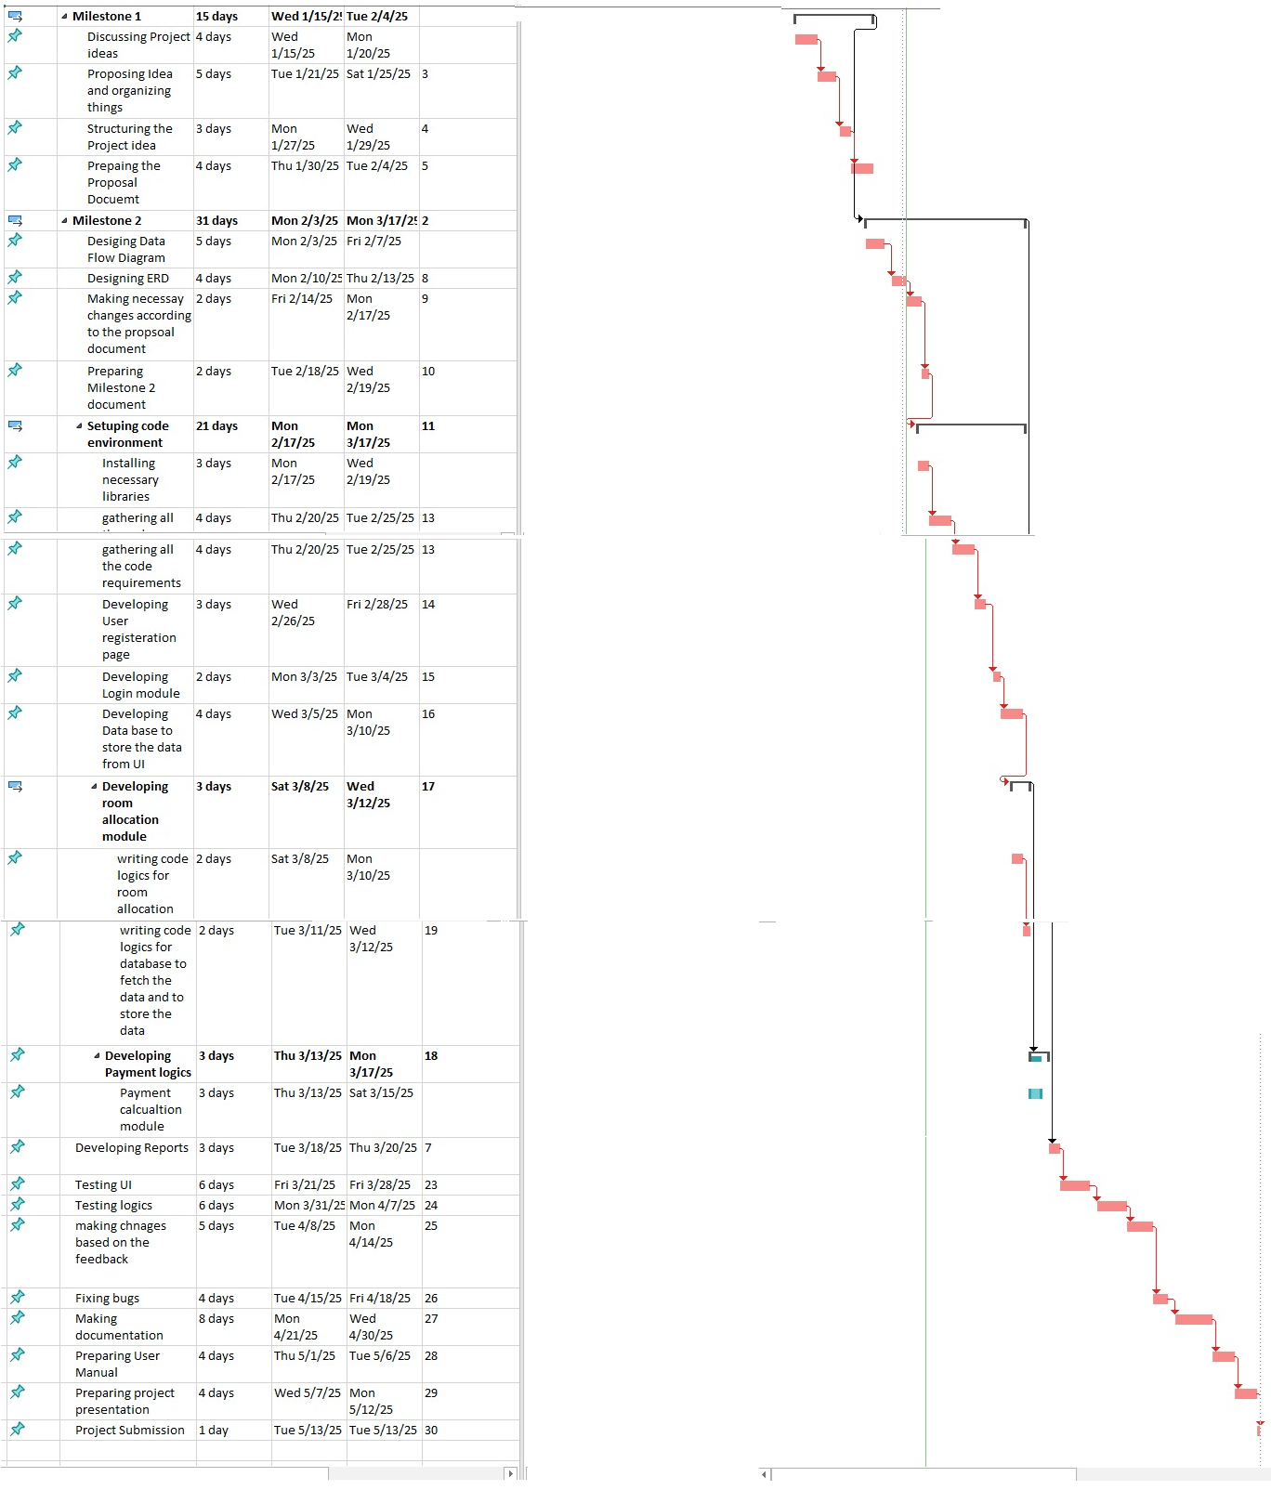

## 8.0 Critical Path



## 9.0 ERD

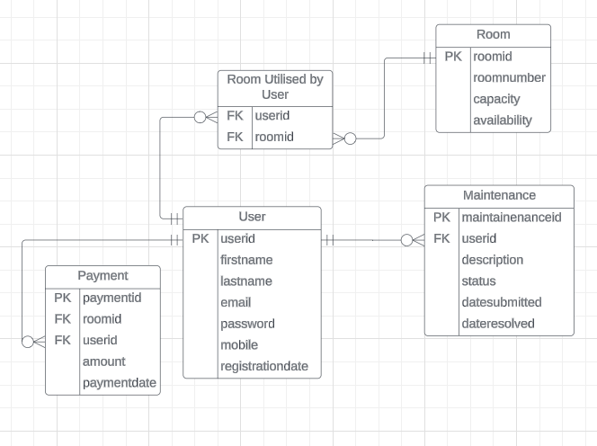

## 10.Screens Designs

Login Screen

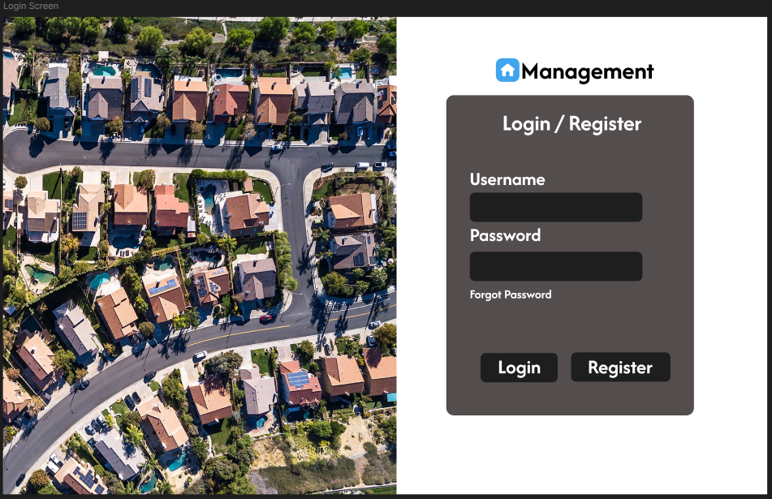

Sign Up Screen

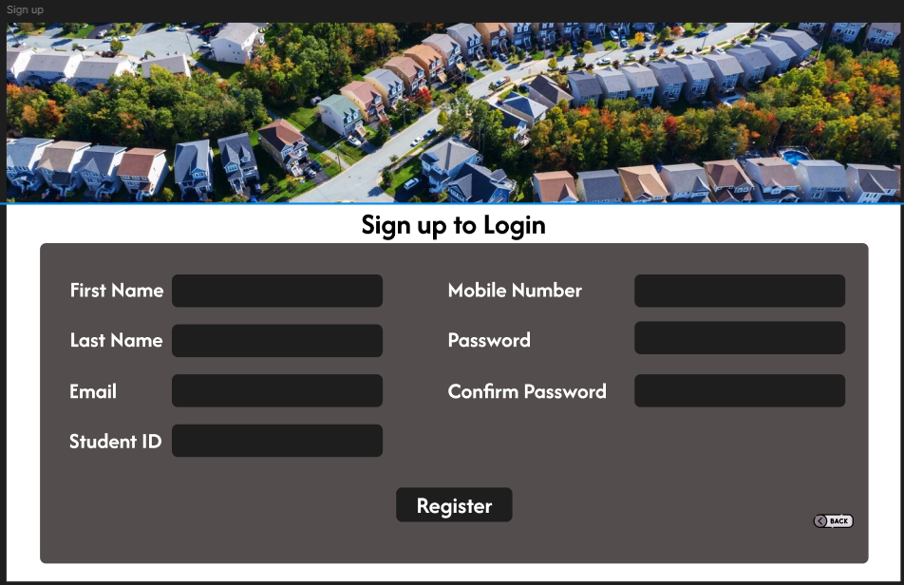

User Dashboard

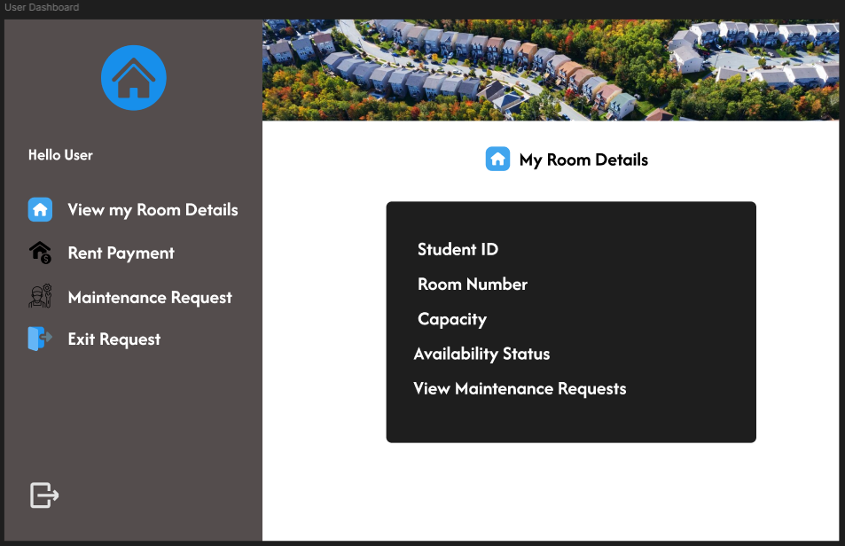

Rent Payment

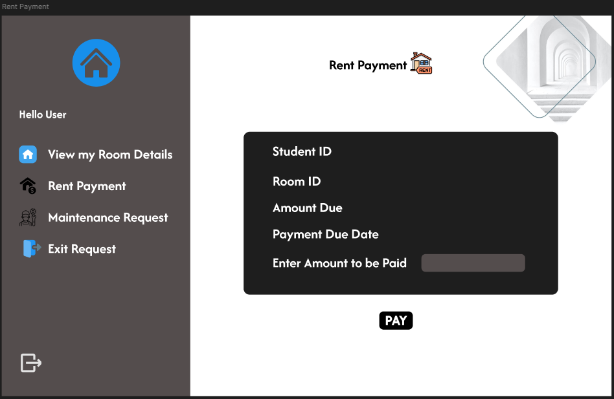

Maintenance Request

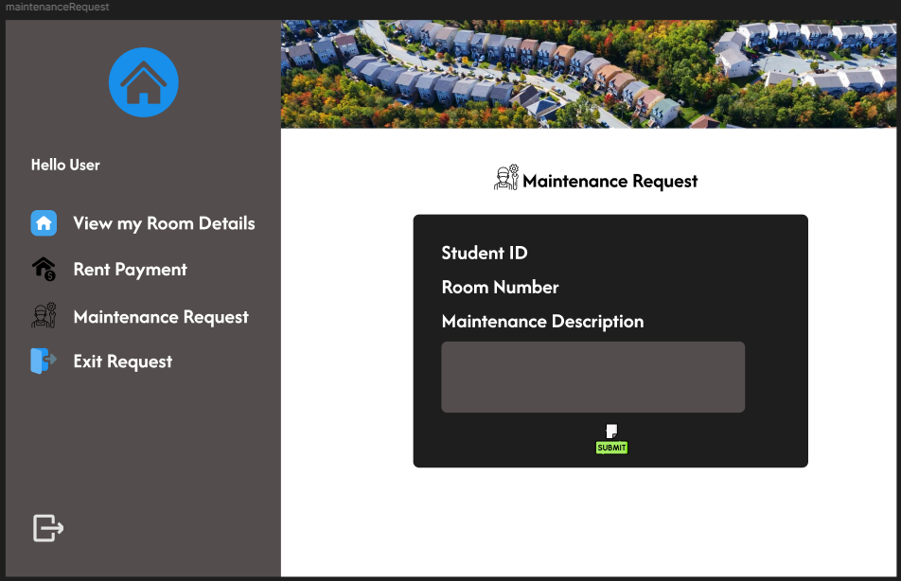

Exit Request

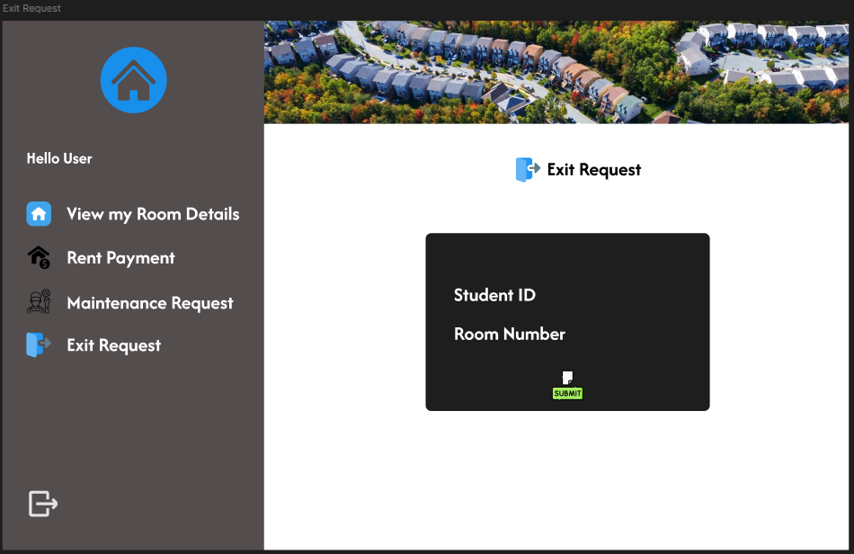

Admin Dashboard

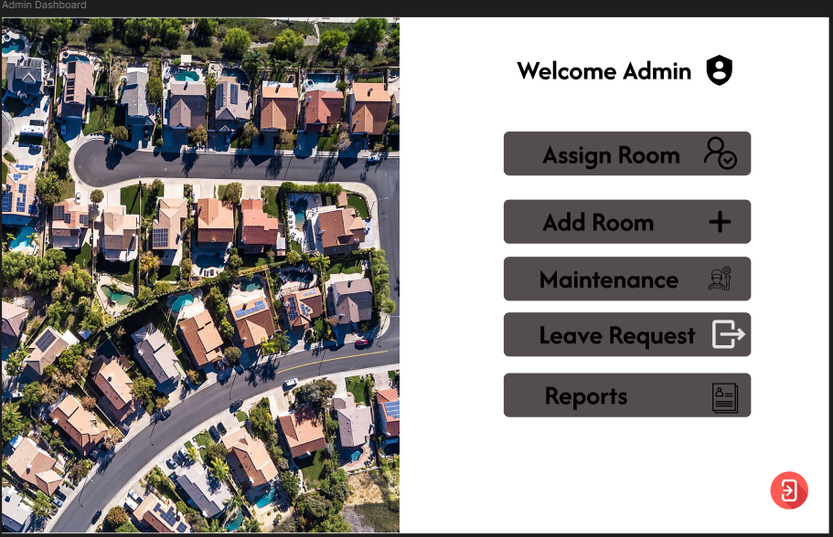

Room Assign Screen

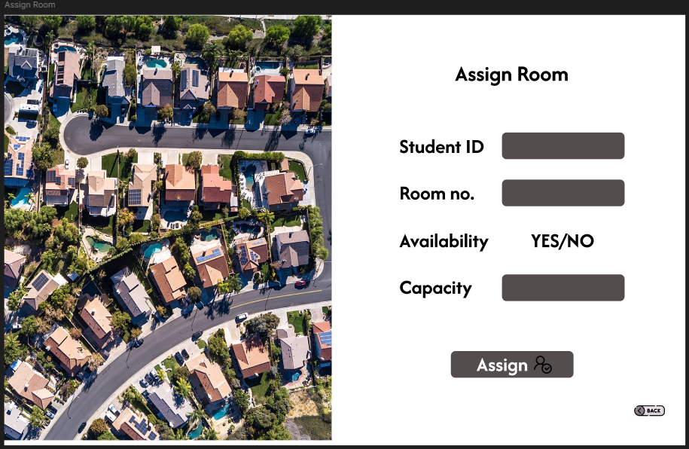

Add room

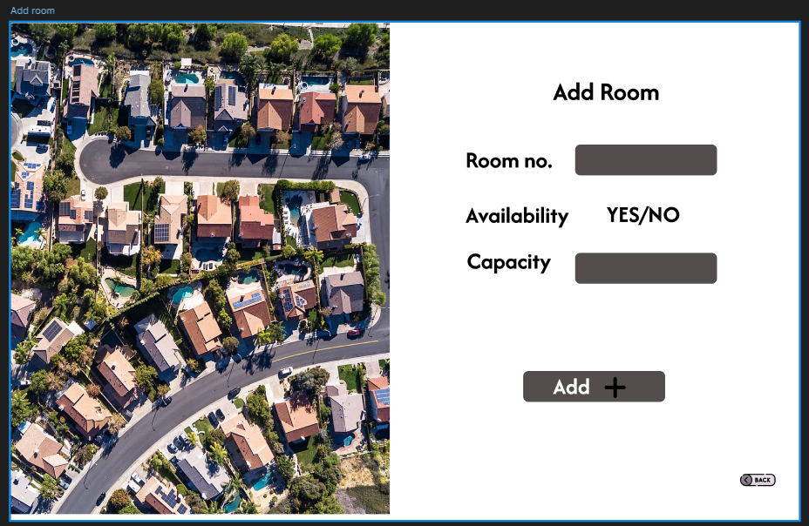

Leave Request

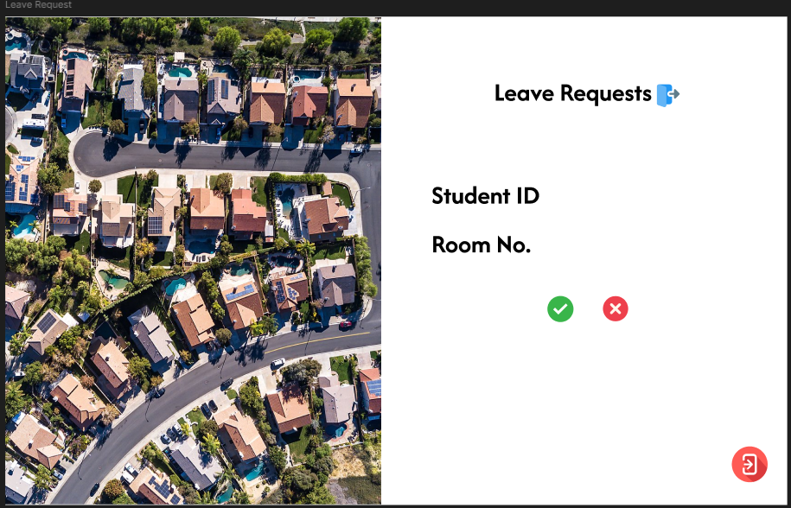

Maintenance Request

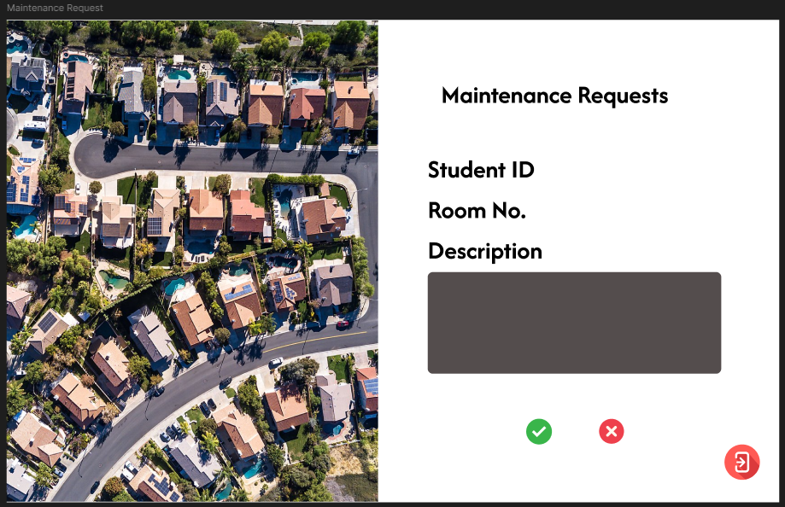

## 11. Conclusion

The **Housing Management System** provides a digital solution to streamline hostel operations by simplifying student registration, room allocation, rent tracking, maintenance requests, and guest entry management. It is both technically and economically feasible, with a structured development timeline ensuring timely delivery. By automating key hostel management functions, this system enhances efficiency, reduces manual workload, and improves the overall accommodation experience for students and administrators.